MK Fowlkes

[Paul.fowlkes@snhu.edu](mailto:Paul.fowlkes@snhu.edu)

CS-230 UML DIAGRAM 1-5

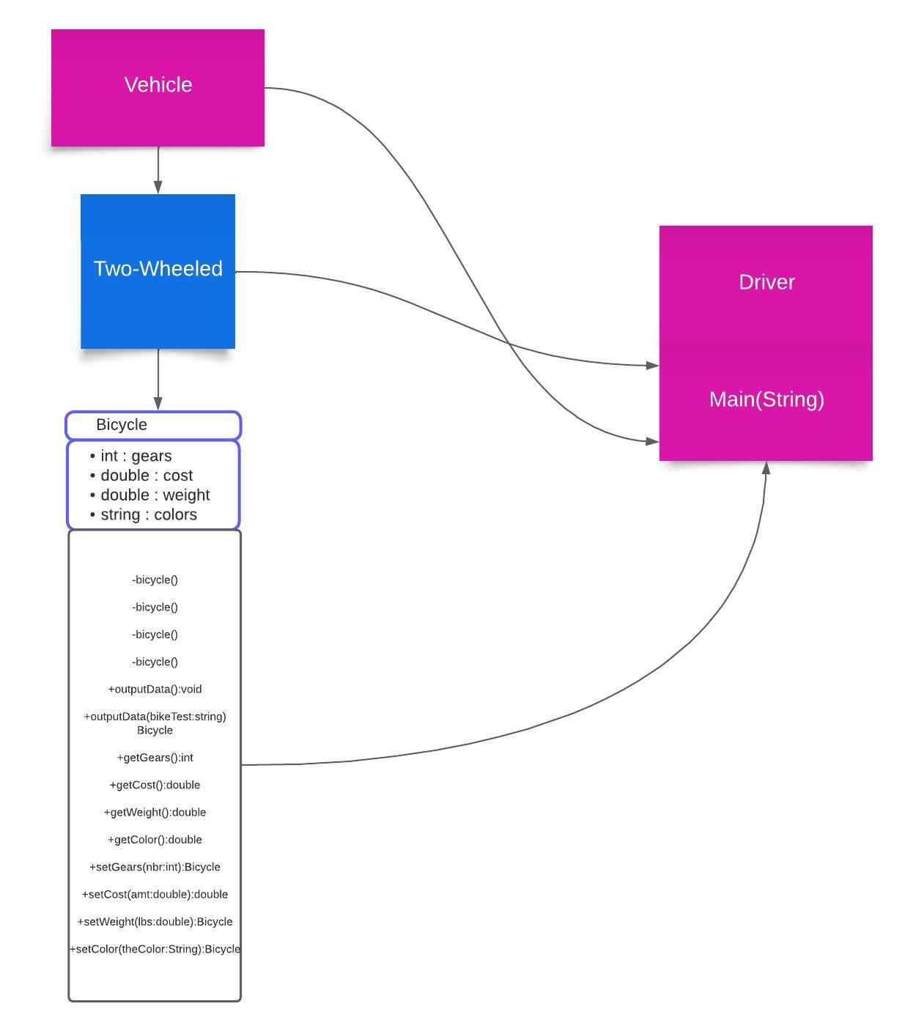

The Vehicle class is shown as the parent class in the UML class diagram, followed by the TwoWheeled class as its child and the Bicycle class as TwoWheeled's child. The arrows taken from the matching parent class indicate inheritance. Two-wheeled vehicles are vehicles, and bicycles are one kind of two-wheeled vehicle. All private instance variables, public methods with three constructors, and accessors and mutators for those instance variables are contained in the Bicycle class. Because the driver class has no associations with other classes and is static, it is not included in the UML.It is not required to be in the UML, even though it is theoretically feasible to create.